St. Thomas Peewee A Stars Repeat as Early Bird Champs
The St. Thomas Peewee A Stars are off to a strong start in their 2017-18 season. The boys tuned up for the season at an exhibition tournament in Leamington and Harrow during the first weekend of September, coming away with the top spot against some very tough U.S. competition from St. Clair Shores, Saginaw and Kensington Valley.

The team then travelled to the Richmond Hill Early Bird Tournament from September 15 to 17 to defend the title they won last year and they did not disappoint. The team went a perfect 6 and 0, securing wins against Caledon, Leaside, Richmond Hill, North Durham, Milton and a convincing 6-2 win in the final against Ottawa-based Leitrim. The team outscored their competition 32 to 10 along the way.

Next up for this group is regular season play as they look to again qualify for AA status in the Alliance League. Come and see this exciting team in action!

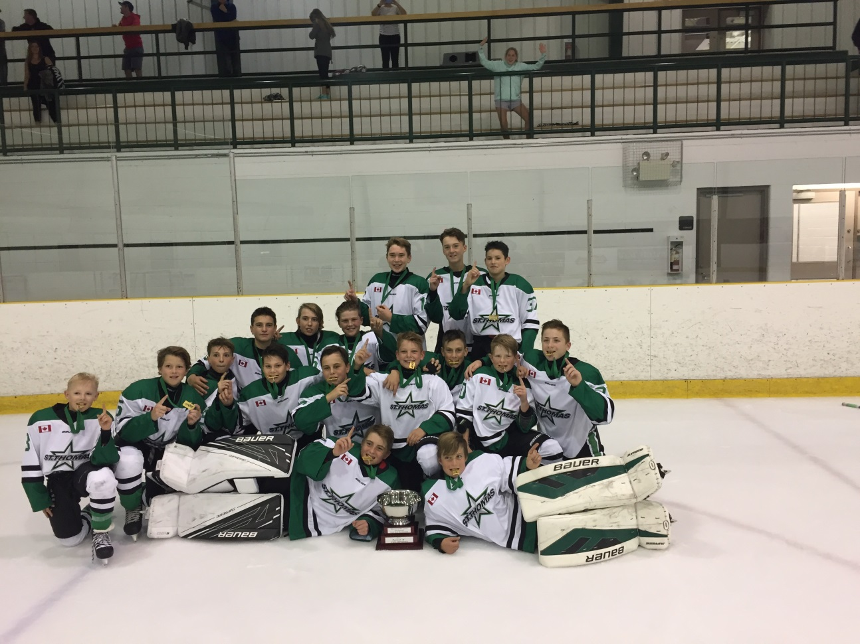

Caption: St. Thomas Peewee A Stars celebrate their tournament win in Richmond Hill.

Front row (l to r): Riley Legacy, Matthew Verbrugge

Second row (l to r): Kalan Gillard, Andrew Roskamp, Justin Babcock, Trent Clinton, Josh Vandenberghe, Kieran Wood, Will O’Brien, Branden Ostrander, Liam Miskelly

Third Row (l to r): Jack Coleman, Kenny Masschaele, Jack Zylstra, Hudson Andrews, Gryffin Gold, Nick Bannister

